## PHASE 2: REQUIREMENT GATHERING

**Functional Requirements**

**Lead (Delivery) Management**

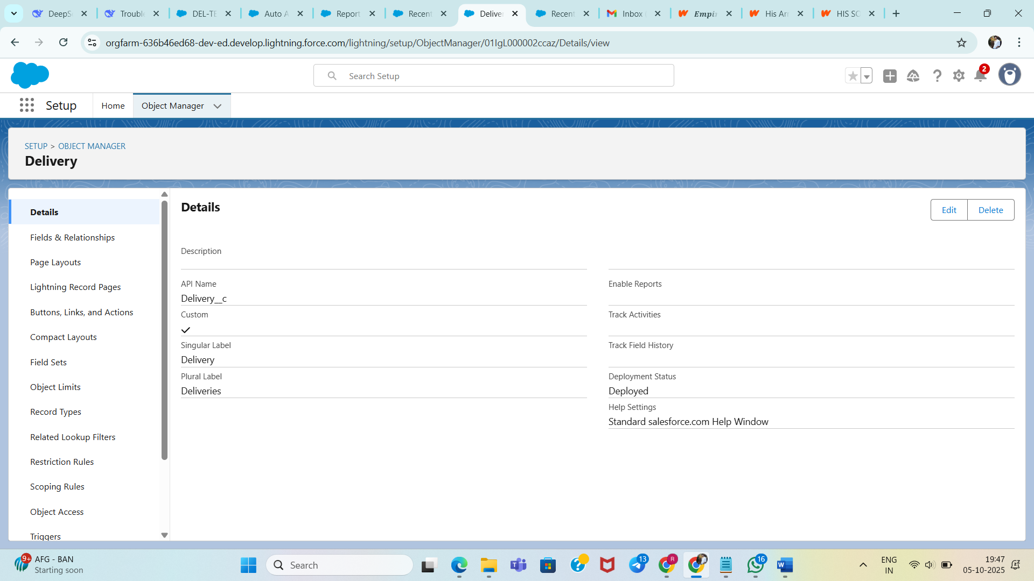

* Multi-channel delivery request capture: Intake from web forms, manual entry by agents, and API integrations.
* Automated driver assignment: Assign each delivery request to the nearest available driver using geolocation and driver capacity.
* Real-time delivery status: Track deliveries through lifecycle stages: Scheduled → Assigned → In-Transit → Delivered → Failed.
* Task automation: Generate follow-up tasks automatically on status changes or exceptions.

**Purpose**: Track delivery requests and assignments

**Object Name**: Delivery__c

**Key Fields**:

* + Delivery_Number__c (Text, Unique) - Tracking identifier
  + Customer_Name__c (Text) - Recipient information
  + Customer_Phone__c (Phone) - Contact details
  + Latitude__c (Number, 9,6) - Delivery location
  + Longitude__c (Number, 9,6) - Delivery location
  + Status__c (Picklist) - Lifecycle tracking
  + Assigned_Driver__c (Lookup) - Driver assignment
  + Estimated_Distance_km__c (Number) - Calculated distance
  + ETA__c (DateTime) - Estimated arrival

**Driver Management**

* Availability & location tracking: Monitor driver locations and statuses in real-time.
* Capacity and shift scheduling: Manage driver work shifts, capacity, and time-off.
* Performance monitoring: Collect data on deliveries completed, timeliness, and SLA breaches.

**Purpose**: Manage delivery drivers and their availability

**Object Name**: Driver__c

**Key Fields**:

* + Phone__c (Phone) - Contact number
  + Current_Latitude__c (Number, 9,6) - Real-time location
  + Current_Longitude__c (Number, 9,6) - Real-time location
  + Status__c (Picklist) - Available, OnTrip, OffDuty
  + Capacity__c (Number) - Vehicle capacity
  + Shift_Start__c (Time) - Work schedule
  + Shift_End__c (Time) - Work schedule

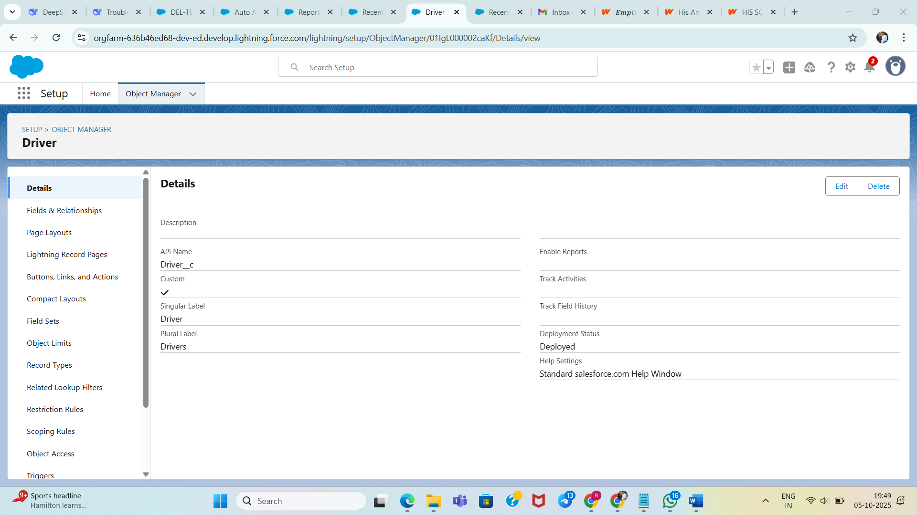

**Hub Operations**

* Geographic hub management: Manage hubs with location, operational territory, and capacity constraints.
* Territory assignments: Link drivers and deliveries to hubs and territories dynamically.
* Capacity planning: Predict delivery volumes and assign resources accordingly.

**Purpose**: Geographic hubs for delivery operations

**Object Name**: Hub__c

**Key Fields**:

* + Hub_Latitude__c (Number, 9,6) - Geographic coordinates
  + Hub_Longitude__c (Number, 9,6) - Geographic coordinates
  + City__c (Text, 50) - Hub location city

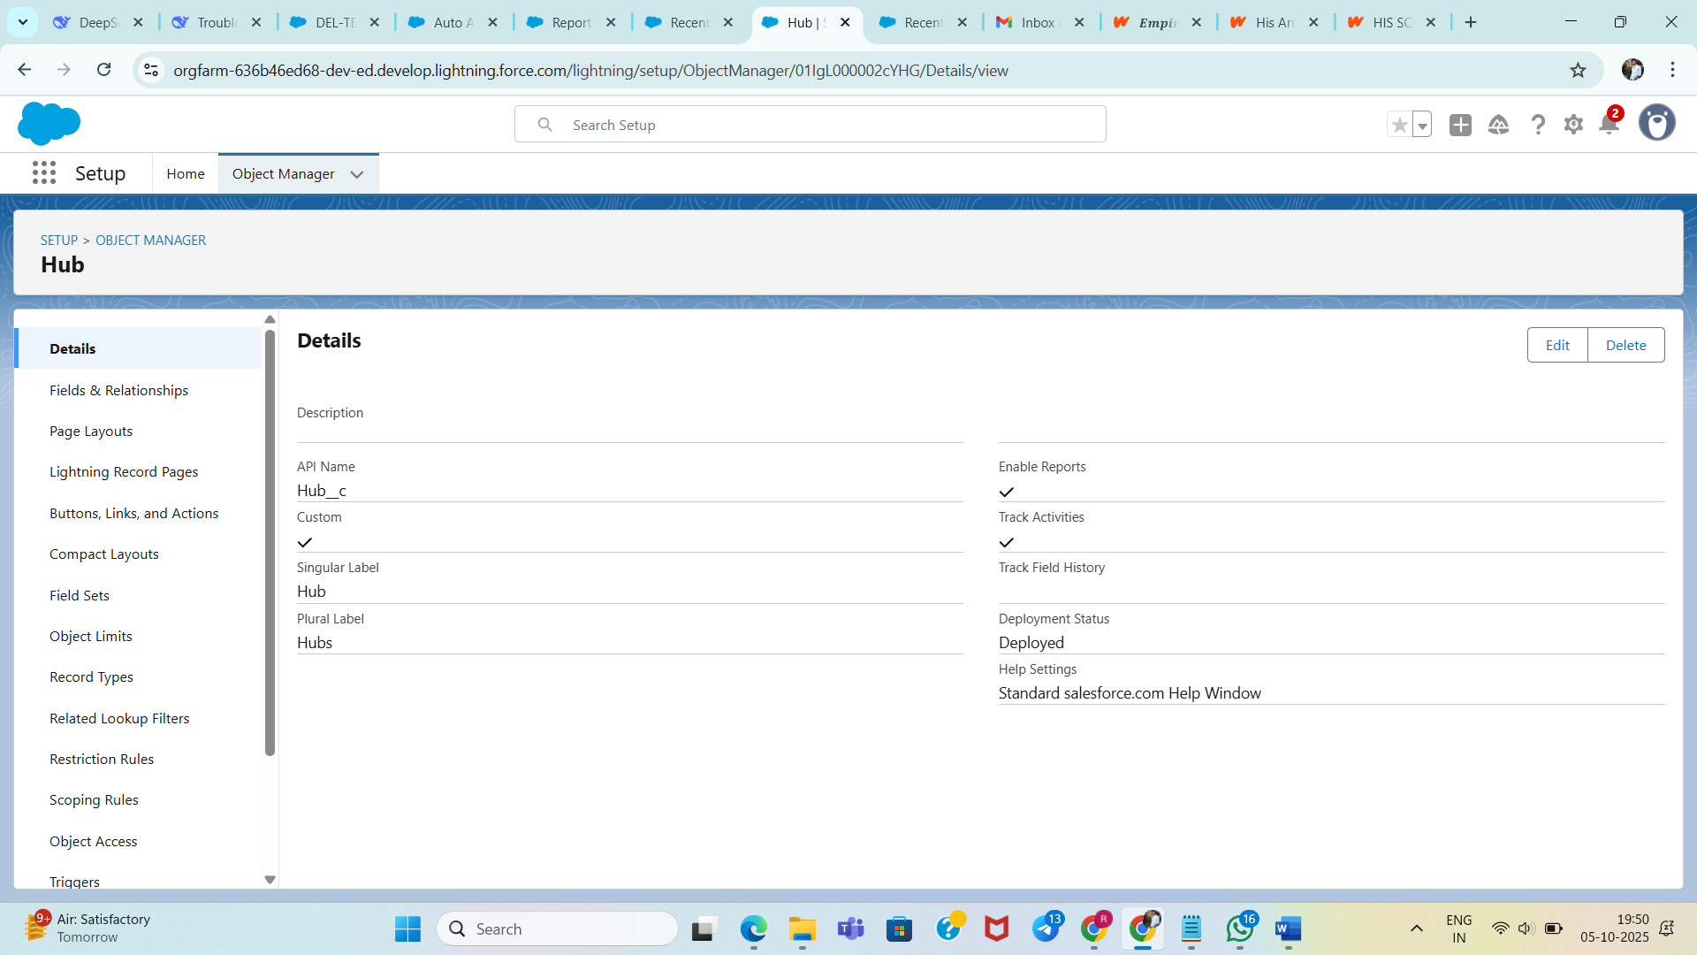

**Customer Experience**

* Accurate ETA calculations: Use distance and driver availability to provide precise ETAs.
* Proactive status notifications: Notify customers on delivery status changes.
* SLA compliance tracking: Monitor SLAs and alert managers on breaches.